SEEDS

Rice

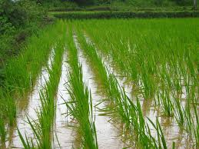

India is the second-largest producer of rice in the world after China. India accounts for approximately 20% of the worlds rice production. It is arguably the most important agricultural crop that grows in the country. Rice is a [staple food](https://www.toppr.com/guides/science/components-of-foods/balanced-diet/) pan India, and its cultivation is also widespread across the country.

Rice prominently grows in high rainfall areas. It requires [average temperatures](https://www.toppr.com/guides/physics/thermal-properties-of-matter/temperature-and-heat/) of 25°c and a minimum of 100 cms of rainfall. It’s traditionally grown in waterlogged rice paddy fields. Northeast plains and coastal areas are the major rice-producing areas of the country.

## Seed quality and selection

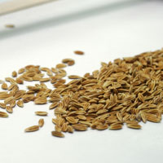Seed is a living product that must be grown, harvested, and processed correctly in order to realize the yield potential of any rice variety. Good quality seed can increase yields by 5-20%. Using good seed leads to lower seeding rates, higher crop emergence, reduced replanting, more uniform plant stands, and more vigorous early crop growth. Vigorous growth in early stages reduces weed problems and increases crop resistance to insect pests and diseases. All of these factors contribute to higher yields and more productive rice farms.

Good seed is pure (of the chosen variety), full and uniform in size, viable (more than 80% germination with good seedling vigor), and free of weed seeds, seed-borne diseases, pathogens, insects, or other matter.

Choosing seed of a suitable variety of rice that suits the environment it will be grown in and ensuring the seed choosen of that variety is of the highest possible quality is the essential first step in rice production.

Land preparation

Before rice can be planted, the soil should be in the best physical condition for crop growth and the soil surface is level. Land preparation involves plowing and harrowing to ‘till’ or dig-up, mix and level the soil.

Tillage allows the seeds to be planted at the right depth, and also helps with weed control. Farmers can till the land themselves using hoes and other equipment or they can be assisted by draft animals, such as buffalo, or tractors and other machinery.

Next, the land is leveled to reduce the amount of water wasted by uneven pockets of too-deep water or exposed soil. Effective land leveling allows the seedlings to become established more easily, reduces the amount of effort required to manage the crop, and increases both grain quality and yields.

## Crop establishment

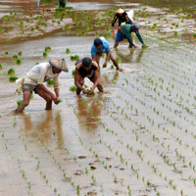

The two main practices of establishing rice plants are transplanting and direct seeding.

***Transplanting*** is the most popular plant establishment technique across Asia. Pre- germinated seedlings are transferred from a seedbed to the wet field. It requires less seed and is an effective method to control weeds, but requires more labor. Seedlings may be transplanted by either machine or hand.

***Direct seeding*** involves broadcasting dry seed or pre-germinated seeds and seedlings by hand or planting them by machine. In rainfed and deepwater ecosystems, dry seed is manually broadcast onto the soil surface and then incorporated either by ploughing or by harrowing while the soil is still dry. In irrigated areas, seed is normally pre- germinated prior to broadcasting.

## Water use and management

Cultivated rice is extremely sensitive to water shortages. To ensure sufficient water, most rice farmers aim to maintain flooded conditions in their field. This is especially true for lowland rice. Good water management in lowland rice focuses on practices that conserve water while ensuring sufficient water for the crop.

In rainfed environments when optimal amounts of water may not be available for rice production, a suite of options are available to help farmers cope with different degrees and forms of water scarcity. It includes sound land preparation and pre-planting activities followed by techniques such as saturated soil culture, alternate wetting and drying, raised beds, mulching, and use of aerobic rice that can cope with dryer conditions.

## Nutrient management

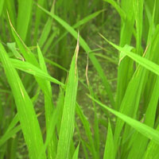At each growth stage, the rice plant has specific nutrient needs. This makes nutrient management a critical aspect of rice farming.

The unique properties of flooded soils make rice different from any other crop. Because of prolonged flooding in rice fields, farmers are able to conserve soil organic matter and also receive free input of nitrogen from biological sources, which means they need little or no nitrogen fertilizer to retain yields. However, farmers can tailor nutrient management to the specific conditions of their field to increase yields.

## Crop health

The rice plant has a wide array of ‘enemies’ in the field. These include rodents, harmful insects, viruses, diseases, and weeds. Farmers manage weeds through water management and land preparation, by hand weeding, and in some cases herbcide application. Understanding the interactions among pests, natural enemies, host plants, other organisms, and the environment allows farmers to determine what if any pest management may be necessary.

Avoiding conditions that allow pests to adapt and thrive in a particular ecosystem helps to identify weak links in the pests' life cycle and therefore what factors can be manipulated to manage them. Retaining natural ecosystems such that predators and natural enemies of pests and diseases are kept in abundance can also help keep pest numbers down.

## Harvest

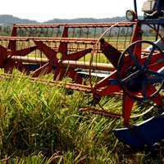

Harvesting is the process of collecting the mature rice crop from the field. Depending on the variety, a rice crop usually reaches maturity at around 105–150 days after crop establishment. Harvesting activities include cutting, stacking, handling, threshing, cleaning, and hauling. Good harvesting methods help maximize grain yield and minimize grain damage and deterioration.

Harvesting can be done manually or mechanically:

***Manual harvesting*** is common across Asia It involves cutting the rice crop with simple hand tools like sickles and knives. Manual harvesting is very effective when a crop has lodged or fallen over, however it is labor intensive. Manual harvesting requires 40 to 80 hours per hectare and it takes additional labor to manually collect and haul the harvested crop.

***Mechanical harvesting*** using reapers or combine harvesters is the other option, but not so common due to the availability and cost of machinery. Following cutting the rice must be threshed to separate the grain from the stalk and cleaned. These processes can also be done by hand or machine.

### Maize

After rice and wheat, maize is the most important cereal crop in India. It accounts for approximately one-tenth of the total agricultural produce in India. Cultivation of maize is focused in the regions of Andhra Pradesh and Karnataka. It requires temperatures in the range of 21°c to 27°c and rainfall of between 50 cms to 75 cms.

### Step 1: Field selection

There are three key aspects of field selection:

**Altitude:** Maize is a sub-tropical plant and the altitude at which it is grown is critical to its ability to mature.

Wherever the crop is grown above 140m there must be other factors to favour of growing at this height, such south-facing and free-draining soil.

**Aspect:** Aim for south-facing sites that are not too exposed.

**Soil type:** Maize needs a dry soil in the spring, but not a soil type that will dry out too much in late spring when the young plants are developing.

Growing maize on heavy, clay-type soils is probably the biggest handicap to trying to get the best out of this crop because of the difficulty in creating the correct seed-bed in the spring.

Medium loams that are easy to work in the spring, free-draining and will warm up early in the season to enable the young plants to get the best possible start are the most favoured.

Very free-draining and light, sandy soils can be too extreme.

### Step 2: Seed-bed preparation

The aim is to achieve a deep, loose seed-bed. Maize is a free-rooting plant so there needs to be no restriction on root development in the early stages.

Crops that struggle with compaction then struggle to mature and achieve optimum yield.

Farms with heavy soils often need to winter plough to achieve the correct seed-bed in the spring. But if there is a wet March, water can hold under the furrows and can take a long time to dry out.

The topsoil can look dry and good, but it’s important to look deeper down and see what conditions are really like.

**See also:**[**Dairy farmer increases maize yields by upping seed rates**](http://www.fwi.co.uk/livestock/dairy-farmer-increases-maize-yields-by-upping-seed-rates.htm)

Crumblers and other machinery that will cultivate the ground to achieve the openness of the soil that maize requires for sowing should be used rather than any kit that will compact the bed. Being able to kick a foot through soils is a good guide.

### Step 3: Drilling and sowing

Maize seed should be drilled to a uniform depth and into moisture.

Soil temperatures should by 8C first thing in the morning for four to five consecutive days for maize to grow.

The last 10 days of April should see all maize drilled, but climate will obviously depend on location.

There is an old adage that says for every day that the crop is sown into the month of May there will be a 1% loss in yield.

With seed treatments likely to be banned next year (2020), farmers should drill deeper to avoid rook damage. Seed must be deeper than a rook’s beak and so should be sown into the seedbed at least 7-8cm.

## Explore moreKnow How

To ensure correct sowing depth, growers should check behind the drill and uncover at least one-meter length of seed to ensure drilling depth and spacing are uniform.

When seed is drilled deeper the seedbed is likely to be colder so growers should expect delayed germination. To offset this, it may be worth taking soil temperatures at 7-8cm deep and drilling later into warmer soils.

Maize seed can come through from a deeper sowing, but if the soil conditions mean that it takes a long time to emerge, and then comes through into inclement spring weather, there will be losses.

All sorts of drills have been evaluated for maize over the years, but most growers come back to precision drills and 76cm rows. Maize needs drilling slowly with one seed delivered every 11-13cm.

### Step 4: Choosing a variety

This should be based on experience of what has already been grown or what is being grown successfully on farms where conditions are similar.

Yield is paramount for dairy farmers growing forage maize and must be a high priority in variety choice.

A modest target is 49.9t/ha (20t/acre) freshweight. Always select a variety that has the potential to give the level of maturity needed by the end of October.

### Step 5: Weed control

Once drilled, all fields should receive a pre-emergent herbicide to combat weeds.

This will also mean post-emergence herbicides have less work to do.

Don’t delay weed control. Once they reach the 2-leaf stage they will start out-competing maize.

Maize is very poor at competing with weeds in its earliest stages of development so this must be avoided.

### Step 6: Crop nutrition

Nitrogen is the driver and a lot of crops just don’t get enough because of an over-estimation of what the slurry can provide.

Maize requires:

* 180kg/ha of potash
* 40kg/ha of phosphate
* And 150kg/ha of Nitrogen

Although these will vary depending on soil indices or where large quantities of FYM or slurry have been applied there should be no requirement for P and K.

Therefore, farmers need to know precisely what nutrients have been applied by slurry or FYM.

Ideally, the application of nitrogen should be split with 75% in the seedbed and the remaining 25% applied at the 1-3 leaf stage. This will help the crop get through its yellow phase often seen at emergence.

### Step 7: Pests and diseases

When maize follows grass there can be pest problems such as wire worms, but growers need to be aware that leather jacket and frit-fly sprays are banned after 31 March.

Although maize is a relatively pest-free crop to grow, the removal of these treatments may have an impact in the future.

European corn-borer has been a problem in the South West and eye-spot can also occur in some crops.

Insecticide dressings can be applied at drilling and there is a fungicide dressing to prevent rotting of the newly drilled seed.

These dressings break down after 21 days so there can be a risk where there is slow emergence of seed in cold, wet seed-beds.

### Wheat

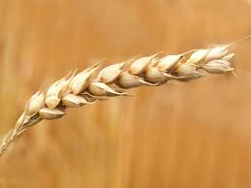

India is the second-largest producer of wheat in the world. It is highly dependent on this rabi crop for its agricultural income. Wheat is a staple food among Indians, especially in the northern regions.

Wheat requires cool temperatures during its growing season in the range of about 14°c to 18°c. [Rainfall](https://www.toppr.com/bytes/why-does-it-rain/) of about 50 cms to 90 cms is most ideal. However, during harvesting season in the spring, wheat requires bright [sunshine](https://www.toppr.com/guides/science/light/sunlight-white-or-coloured/) and slightly warmer weather. Uttar Pradesh is the largest wheat-growing state in India closely followed by Punjab and Haryana.

**Planning Your Crop**

**1**

**Determine how much space you have.** About 1,000 square feet will yield one bushel, or 60 lbs (30 kg), of grain. That’s about the space of a backyard. You'll need to figure out how much wheat you want to grow and how much space it will take.[[1]](https://www.wikihow.com/Plant-Wheat#_note-1)

**2**

**Determine the type of wheat you'll plant.** Winter wheat is planted in the fall and harvested in early spring. It also tends to be the preferred variety since it is more nutritious and competes with fewer weeds in the spring. Spring wheat is planted in the spring and harvested in the fall. It is the more common variety in areas that have colder winters.

**3**

**Choose your planting location.** Your wheat should get plenty of sun while it grows, so make sure you plant it in full sun. The area where you plant should get about eight hours of sun a day. This is true whether you plant winter or spring wheat. Don't plan on planting your crop anywhere where there's too much shade.[[2]](https://www.wikihow.com/Plant-Wheat#_note-2)

**4**

**Time your planting season.** Prepare to plant winter wheat in the fall, approximately 6 to 8 weeks before the soil freezes, as this allows for strong root growth. Spring wheat can be planted as early as you can work the soil. Wheat grows best in 70 to 75 degree Fahrenheit ((21 to 24 degrees Celsius) weather, so you should plant your wheat when the weather is approaching that temperature (and eventually rising).

**Part2**

**Planting Your Seeds**



**1**

**Till your soil.** You should till your soil to a depth of 6 inches (15 cm). You can use a rake, rototiller, or shovel to prepare the soil, although a rototiller is probably best if you're covering a large area. The ground needs to be as close to even as possible once you're finished, so you might need to run a rake over the top of the soil to even it out.[[3]](https://www.wikihow.com/Plant-Wheat#_note-3)



**2**

**Spread compost if necessary.** If your soil is overly dry (it will be a light brown color) or somewhat rocky, you might need a layer of compost. This provides the soil with extra nutrients and can help the wheat grow better. Soil that is a rich brown color and moist to the touch doesn't need any extra compost. [[4]](https://www.wikihow.com/Plant-Wheat#_note-4)

**3**

**Spread your seeds.** You can use your hand, but an actual seed spreader is best, because it gives you more even coverage. You should spread the seeds so that you have approximately one seed per 1 square inch (2.5 square centimeters) of space. The package of seeds should tell you how many pounds of seed you should use per 1,000 square feet of planting area, to give you a better idea of how much seed you need for large areas.[[5]](https://www.wikihow.com/Plant-Wheat#_note-5)



**4**

**Rake the seeds.** Once you’ve spread the seeds, they need to get worked into the soil. Using a metal rake, gently rake over the seeds so they get worked into the soil. Make sure you rake evenly so your crop doesn't come up in clumps.[[6]](https://www.wikihow.com/Plant-Wheat#_note-6)



**5**

**Cover the seed with a thin layer of soil.** This prevents the seed from drying out in the sun and from birds feeding on it. Cover spring wheat without about 1.5 inches (3.8 cm) of soil. Winter wheat should be 2.5 inches (6.4 cm) deep. The seed should never be covered by more than 3 inches (7.6 cm) of soil.



**6**

**Water your newly planted seeds.** You should soak the area that’s planted right away. Keep the entire planting area moist until the wheat begins to grow. Cooler weather and more rain means less watering on your part.[[7]](https://www.wikihow.com/Plant-Wheat#_note-7)

**Part3**

**Maintaining Your Wheat**



**1**

**Water your plants during dry spells.** If your planting area goes through a dry spell - no rain for a week or so - you'll need to water the planting area. This will probably be more necessary if you're planting winter wheat than if you plant spring wheat.[[8]](https://www.wikihow.com/Plant-Wheat#_note-8)



**2**

**Weed as needed.** Wheat grows very close together, so you might not need to weed regularly. You should, however, keep an eye out for weeds, especially if it's your first time growing and you haven't spread your seeds evenly.[[9]](https://www.wikihow.com/Plant-Wheat#_note-9)

**3**

**Protect your crop from pests.** Slugs and insects like sawflies can destroy a crop of wheat. Slugs are likely to appear when the wheat is still very short, under 4 or 5 inches (9 to 10 cm). If you see them, use slug baits to keep them away from your wheat. If you notice sawflies, spray your crop with insecticide to protect the wheat.[[10]](https://www.wikihow.com/Plant-Wheat#_note-10)

**SOIL**

**AGRO-ECOLOGICAL ZONES**

Agriculture is highly dependent on soils and climate. The ever-increasing need for food to support the growing population in the country demands a systematic appraisal of its soil and climate resources in order to prepare effective land-use plans. India has a variety of landscapes and climate conditions and this is reflected in the development of different soils and types of vegetation. Based on 50 years of climate data and an up-to-date soil database, the country has been divided into 20 agro-ecological zones (AEZs), as shown in Figure 2. 4 Fertilizer use by crop in India Each AEZ is as uniform as possible in terms of physiography, climate, length of growing period and soil type for macrolevel land-use planning and effective transfer of technology. Table 2 gives a brief description of important features of the AEZs.

**MAJOR SOIL GROUPS**

Alluvial soils (Fluvisols) Alluvial soils constitute the largest and most important soil group of India and contribute most to the agricultural wealth of the country. The soils are derived from the deposition of silt by the numerous river systems. They cover about 75 million ha in the Indo-Gangetic Plains (IGP) and Brahmaputra Valley and are distributed in the states of Punjab, Haryana, Uttaranchal, Uttar Pradesh, Bihar, West Bengal, Assam and the coastal regions of India. These soils are deficient in nitrogen (N), phosphorus and organic matter. Generally, alluvial soils range from near neutral to slightly alkaline in reaction. A wide variety of crops is grown in these soils.

**Black soils (Vertisols)**

Black soils are very dark and have a very high clay content. They have a high moisture retention capacity. They become extremely hard on drying and sticky on wetting. Hence, they are very difficult to cultivate and manage. These soils cover an area of about 74 million ha, mainly in the central, western and southern states of India. They are inherently very fertile. Under rainfed conditions, they are used for growing cotton, millets, soybean, sorghum, pigeon pea, etc. Under irrigated conditions, they can be used for a variety of other crops, such as sugar cane, wheat, tobacco and citrus crops.

**Red soils (Acrisols)**

Ancient crystalline and metamorphic rocks have given rise to red soils. These soils are found predominantly in the states of Andhra Pradesh, Tamil Nadu, Karnataka, Maharashtra, Orissa, Goa and in the northeastern states. They have limitations of soil depth, poor water and nutrient-holding capacity, excessive drainage, runoff and are generally poor in N, P, zinc (Zn), sulphur (S) and humus. Under good management, these soils can be used profitably for a variety of crops such as millets, rice, groundnut, maize, soybean, pigeon pea, green gram, jute, tea, cashew, cocoa, grapes, banana, papaya and mango.

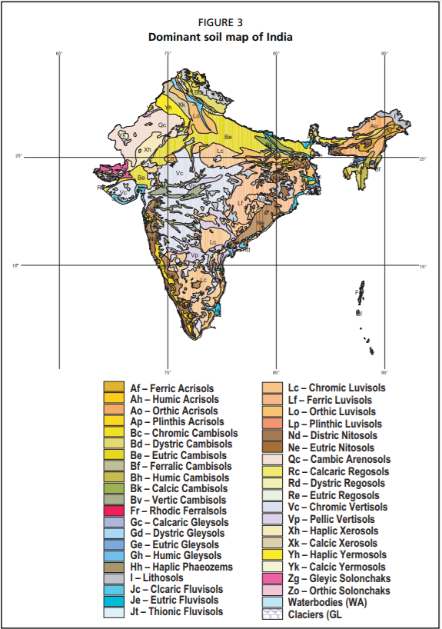

**Fertilizer**

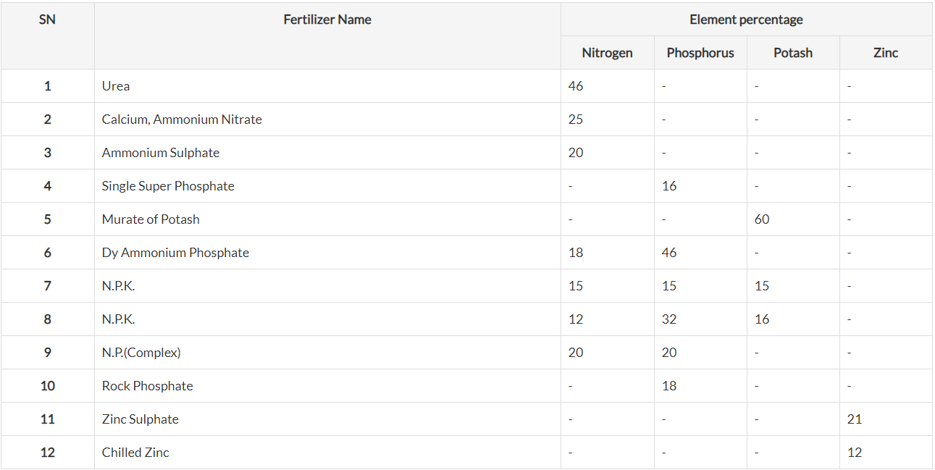

1800-180-1551

Farmers can reach agriculture experts at Kisan Call Centres (KCC) by dialling **1800-180**-**1551**, who will provide solutions and advice to their queries, a release said.Nov 13, 2009

**CROPS UNDER MSP**

|  |  |  |  |  |
| --- | --- | --- | --- | --- |
| **Commodity** | **Variety** | **MSP for 2019-20 (Rs per quintal)** | **MSP for 2020-2021 (Rs per quintal)** | **Increase over previous year (Rs per quintal)** |
| **KHARIF CROPS** | | | | |
| Paddy | Common | 1815 | 1868 | 53 |
|  | Grade 'A' | 1835 | 1888 | 53 |
| Jowar | Hybrid | 2550 | 2620 | 70 |
|  | Maldandi | 2570 | 2640 | 70 |
| Bajra |  | 2000 | 2150 | 150 |
| Maize |  | 1760 | 1850 | 90 |
| Ragi |  | 3150 | 3295 | 145 |
| Arhar (Tur) |  | 5800 | 6000 | 200 |
| Moong |  | 7050 | 7196 | 146 |
| Urad |  | 5700 | 6000 | 300 |
| Cotton | Medium Staple* | 5255 | 5515 | 260 |
|  | Long Staple ** | 5550 | 5825 | 275 |
| Groundnut in shell |  | 5090 | 5275 | 185 |
| Sunflower seed |  | 5650 | 5885 | 235 |
| Soyabeen | Yellow | 3710 | 3880 | 170 |
| Sesamum | - | 6485 | 6855 | 370 |
| Nigerseed | - | 5490 | 6695 | 755 |
| **RABI CROPS (2019-20 season to be marketed in 2020-21)** | | | | |
| Wheat |  | 1840 | 1925 | 85 |
| Barley |  | 1440 | 1525 | 85 |
| Gram |  | 4620 | 4875 | 255 |
| Masur (Lentil) |  | 4475 | 4800 | 325 |
| Rapeseed & Mustard |  | 4200 | 4425 | 225 |
| Safflower |  | 4945 | 5215 | 270 |
| Toria |  | 3560 | 3900 | 340 |
| **OTHER CROPS** | | | | |
| Copra (2020 crop season) | Milling | 9521 | 9960 | 439 |
|  | Ball | 9920 | 10300 | 380 |
| De-husked coconut |  | 2571 | 2700 | 129 |
| Raw Jute (for 2019-20 season) |  |  | 3950 | - |
| Sugarcane $ |  |  | 275 | - |

|  |  |  |
| --- | --- | --- |
| **SNo** | **State** | **Total Valid Dealer** |
| 1 | A AND N ISLANDS | [18](https://farmer.gov.in/Seed/SeedReport.aspx?SCode=31) |
| 2 | ANDHRA PRADESH | [2139](https://farmer.gov.in/Seed/SeedReport.aspx?SCode=01) |
| 3 | ASSAM | [1154](https://farmer.gov.in/Seed/SeedReport.aspx?SCode=02) |
| 4 | BIHAR | [5706](https://farmer.gov.in/Seed/SeedReport.aspx?SCode=03) |
| 5 | CHHATTISGARH | [2524](https://farmer.gov.in/Seed/SeedReport.aspx?SCode=23) |
| 6 | DELHI | [6](https://farmer.gov.in/Seed/SeedReport.aspx?SCode=35) |
| 7 | GUEST | [4](https://farmer.gov.in/Seed/SeedReport.aspx?SCode=85) |
| 8 | GUJARAT | [14235](https://farmer.gov.in/Seed/SeedReport.aspx?SCode=04) |
| 9 | HARYANA | [4080](https://farmer.gov.in/Seed/SeedReport.aspx?SCode=05) |
| 10 | HIMACHAL PRADESH | [721](https://farmer.gov.in/Seed/SeedReport.aspx?SCode=06) |
| 11 | JAMMU&KASHMIR | [353](https://farmer.gov.in/Seed/SeedReport.aspx?SCode=07) |
| 12 | JHARKAND | [2634](https://farmer.gov.in/Seed/SeedReport.aspx?SCode=24) |
| 13 | KARNATAKA | [7589](https://farmer.gov.in/Seed/SeedReport.aspx?SCode=08) |
| 14 | KERALA | [247](https://farmer.gov.in/Seed/SeedReport.aspx?SCode=09) |
| 15 | MADHYA PRADESH | [10487](https://farmer.gov.in/Seed/SeedReport.aspx?SCode=10) |
| 16 | MAHARASHTRA | [31606](https://farmer.gov.in/Seed/SeedReport.aspx?SCode=11) |
| 17 | MEGHALAYA | [8](https://farmer.gov.in/Seed/SeedReport.aspx?SCode=13) |
| 18 | MIZORAM | [14](https://farmer.gov.in/Seed/SeedReport.aspx?SCode=38) |
| 19 | NAGALAND | [5](https://farmer.gov.in/Seed/SeedReport.aspx?SCode=14) |
| 20 | ORISSA | [17](https://farmer.gov.in/Seed/SeedReport.aspx?SCode=15) |
| 21 | PUDUCHERRY | [53](https://farmer.gov.in/Seed/SeedReport.aspx?SCode=39) |
| 22 | PUNJAB | [6005](https://farmer.gov.in/Seed/SeedReport.aspx?SCode=16) |
| 23 | RAJASTHAN | [10874](https://farmer.gov.in/Seed/SeedReport.aspx?SCode=17) |
| 24 | SIKKIM | [5](https://farmer.gov.in/Seed/SeedReport.aspx?SCode=22) |
| 25 | TAMILNADU | [5346](https://farmer.gov.in/Seed/SeedReport.aspx?SCode=18) |
| 26 | TELANAGANA | [2668](https://farmer.gov.in/Seed/SeedReport.aspx?SCode=26) |
| 27 | TRIPURA | [22](https://farmer.gov.in/Seed/SeedReport.aspx?SCode=19) |
| 28 | UTTAR PRADESH | [20223](https://farmer.gov.in/Seed/SeedReport.aspx?SCode=20) |
| 29 | UTTARAKHAND | [1](https://farmer.gov.in/Seed/SeedReport.aspx?SCode=25) |
| 30 | WEST BENGAL | [1890](https://farmer.gov.in/Seed/SeedReport.aspx?SCode=21) |
|  | **Total** | **130634** |

* **This is the list of all the dealers that are currently active in INDIA (state wise).**
* **We can show a page where if a farmer selects his state he’ll get the list of all the dealers as well as their contact information. So he can have options.**
* **All the dealers are registered and verified so there are no chances of scams**.

# *Do’s and Don’ts in safe use of pesticides by the farmers while purchasing and using*

|  |  |
| --- | --- |
| **Do’s** | **Don’ts** |
| **While Purchasing:** ✅ Purchase pesticides/biopesticides only from Registered pesticide dealers having valid Licence. ✅ Purchase only just required quantity of pesticides for single operation in a specified area. ✅ See approved labels on the containers/packets of pesticides. ✅ See Batch No., Registration Number, Date of Manufacture/ Expiry on the labels. ✅ Purchase pesticides well packed in containers. | ✤ Do not purchase pesticides from foot path dealers or from un-licenced person. ✤ Do not purchase pesticide in bulk for whole season. ✤ Do not purchase pesticides without approved label on the containers. ✤ Never purchase expired pesticide. ✤ Do not purchase pesticides whose containers are leaking/loose/ unsealed. |
| **During Storage:** ✅ Store the pesticides away from house premises. ✅ Keep pesticides in original containers. ✅ Pesticides/weedicides must be stored separately. ✅ Where pesticides have been stored,area should be marked with warning signs. ✅ Pesticides be stored away from the reach of the children and live stocks. ✅ Storage place should be well protected from direct sunlight and rain. | ✤ Never store pesticide in house premises. ✤ Never transfer pesticides from original to another containers. ✤ Do not store insecticides with weedicides. ✤ Do not allow children to enter the storage place. ✤ Do not allow children to enter the storage place. ✤ Pesticides should not be exposed to sunlight or rain water. |
| **While handling:** ✅ Keep pesticides separate during transportation. ✅ Bulk pesticides should be carried tactfully to the site of application. | ✤ Never carry/transport pesticides along with food/fodder/other eatable articles. ✤ Never carry bulk pesticides on head, shoulder or on the back. |
| **While preparing spray solution:** ✅ Always use clean water. ✅ Use protective clothings viz., hand gloves, face masks, cap, apron, full trouser, etc. to cover whole body. ✅ Always protect your nose, eyes, ears, hands, etc. from spill of spray solution. ✅ Read instructions on pesticide container label carefully before use. ✅ Prepare the solution as per requirement. ✅ Granular pesticides should be used as such. ✅ Avoid spilling of pesticides solutions while filling the spray tank. ✅ Always use recommended dosage of pesticide. ✅ No activities should be carried out which may affect your health. | ✤ Do not use muddy or stagnant water. v Never prepare spray solution without wearing protective clothings. ✤ Do not allow the pesticide/its solution to fall on any body parts. v Never avoid reading instructions on container’s label for use. ✤ Never use left out spray solution after 24 hours of its preparation. ✤ Do not mix granules with water. ✤ Do not smell the spray tank. ✤ Do not use overdose which may affect plant health and environment. ✤ Do not eat, drink, smoke or chew during whole operation of pesticides. |
| **Selection of Equipments:** ✅ Select right kind of equipments. ✅ Select right sized nozzles. ✅ Use separate sprayer for insecticides and weedicides. | ✤ Do not use leaky or defective equipments. ✤ Do not use defective/non- recommended nozzles.Do not blow/clean clogged nozzles with mouth.Instead use tooth brush tied with sprayer. ✤ Never use same sprayer for both weedicides and insecticides. |
| **While applying spray solutions** ✅ Apply only recommended dose and dilution. ✅ Spray operation should be conducted on cool and calm day. ✅ Spray operation should be conducted on sunny day in general. ✅ Use recommended sprayer for each spray. ✅ Spray operation should be conducted in the wind direction. ✅ After spray operation, sprayer and buckets should be washed with clean water using detergent/soap. ✅ Avoid the entry of animals/workers in the field immediately after spray. | ✤ Never apply over-dose and high concentrations than recommended. ✤ Do not spray on hot sunny day or strong windy conditions. ✤ Do not spray just before rains and immediately after the rains. ✤ Emulsifiable concentrate formulations should not be used for spraying with battery operated ULV sprayer. ✤ Do not spray against wind direction. ✤ Containers and buckets used for mixing pesticides should never be used for domestic purpose even after thorough washing. ✤ Never enter in the treated field immediate after spray without bearing protective clothings. |
| **After Spray Operation:** ✅ Left over spray solutions should be disposed off at safer place viz. barren isolated area. ✅ The used/empty containers should be crushed with stone/stick and buried deep in soil away from water sources. ✅ Wash hands and face with clean water and soap before eating/smoking. ✅ On observing poisoning symptoms give the first aid and show the patient to doctor. Also show the empty container to doctor. | ✤ Left over spray solution should not be drained in or near ponds or water lines etc. ✤ Empty containers of pesticides should not be re-used for storing other articles. ✤ Never eat/smoke before washing clothes and taking bath. ✤ Do not take the risk by not showing the poisoning symptoms to doctor as it may endanger the life of the patien |